PREPARATION FOR THE “LAST DAYS”  Part 2: Difficult times – what do we do? | Questions?  If it is true that we are in the “last days”, then what should our response be? Are we to simply sit back and relax until the Lord comes? Should we work ourselves to death? These questions and many more are set forth for discussion in this study guide, which is the second part of “Preparations for the Last Days”.  Subjects in part 2:  - What do I do (attitude)  - You are the salt of the earth  - You are the light of the world  - Walk as children of light  - Who are you following?  - Instructions for the last days  - Keep your focus  - Be patient God is up to something  - God will reward you

Difficult Times: What Do I Do?

I
t is true that we are in difficult times. But what have we been told to do about it? Do we simply sit back and wait for Jesus to come and do nothing? Or should we work ourselves to death? What should our response be?

Q – Since times are becoming more difficult and people are going away from the truth in Christ, what do you think that we should be doing?

For the answer to this question, we must consider what is called “the sermon on the mount”. This was a message that He presented to those who had been changed by Him and were following Him. Most of his audience were not Pharisees, Sadducees, Herodians, Scribes, Priests, Levites, or any of the religious people of his day. He was speaking to normal, average people who were becoming His disciples.

Matthew 5:1-16
And seeing the multitudes, He went up on a mountain, and when He was seated His disciples came to Him. Then He opened His mouth and taught them, saying:
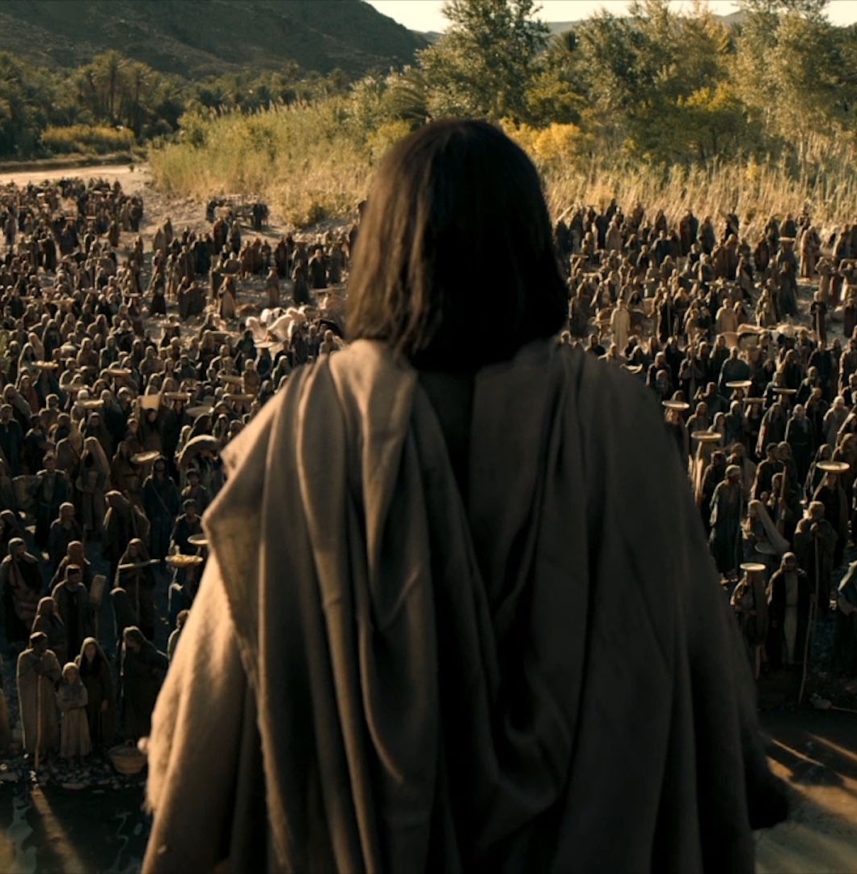
"Blessed are the poor in spirit,
For theirs is the kingdom of heaven.
Blessed are those who mourn,
For they shall be comforted.
Blessed are the meek,
For they shall inherit the earth.
Blessed are those who hunger and thirst for righteousness,
For they shall be filled.
Blessed are the merciful,
For they shall obtain mercy.
Blessed are the pure in heart,
For they shall see God.
Blessed are the peacemakers,
For they shall be called sons of God.
Blessed are those who are persecuted for righteousness' sake,
For theirs is the kingdom of heaven.

"Blessed are you when they revile and persecute you, and say all kinds of evil against you falsely for My sake. Rejoice and be exceedingly glad, for great is your reward in heaven, for so they persecuted the prophets who were before you.

"You are the salt of the earth; but if the salt loses its flavor, how shall it be seasoned? It is then good for nothing but to be thrown out and trampled underfoot by men. "You are the light of the world. A city that is set on a hill cannot be hidden. Nor do they light a lamp and put it under a basket, but on a lampstand, and it gives light to all who are in the house. Let your light so shine before men, that they may see your good works and glorify your Father in heaven.

Jesus said: “You are the salt of the earth!”, and “You are the light of the world!”

Q – Who was he referring to when he made these statements? Who did he consider to be the salt of the earth and the light of the world?

In order to be the salt of the earth and the light of the world, this is what Jesus said that we must be like:

Q - We must be “poor in spirit” – what does he mean by this phrase?

Isaiah 57:15
For thus says the High and Lofty One
Who inhabits eternity, whose name is Holy:
"I dwell in the high and holy place,
With him who has a contrite and humble spirit,
To revive the spirit of the humble,
And to revive the heart of the contrite ones.

To be “poor in spirit”. Means to have a humble and contrite heart. Or, in other words, to have a humble opinion of ourselves, knowing that we cannot be righteous by our own works and recognises our spiritual poverty apart from God.

Q - We must be those who mourn – does this mean that we cry easily?

Luke 7:36-48
Then one of the Pharisees asked Him to eat with him. And He went to the Pharisee's house, and sat down to eat. And behold, a woman in the city who was a sinner, when she knew that Jesus sat at the table in the Pharisee's house, brought an alabaster flask of fragrant oil, and stood at His feet behind Him weeping; and she began to wash His feet with her tears, and wiped them with the hair of her head; and she kissed His feet and anointed them with the fragrant oil. Now when the Pharisee who had invited Him saw this, he spoke to himself, saying, "This Man, if He were a prophet, would know who and what manner of woman this is who is touching Him, for she is a sinner."

And Jesus answered and said to him, "Simon, I have something to say to you." So he said, "Teacher, say it."

"There was a certain creditor who had two debtors. One owed five hundred denarii, and the other fifty. And when they had nothing with which to repay, he freely forgave them both. Tell Me, therefore, which of them will love him more?"

Simon answered and said, "I suppose the one whom he forgave more."

And He said to him, "You have rightly judged." Then He turned to the woman and said to Simon, "Do you see this woman? I entered your house; you gave Me no water for My feet, but she has washed My feet with her tears and wiped them with the hair of her head. You gave Me no kiss, but this woman has not ceased to kiss My feet since the time I came in. You did not anoint My head with oil, but this woman has anointed My feet with fragrant oil. Therefore I say to you, her sins, which are many, are forgiven, for she loved much. But to whom little is forgiven, the same loves little." Then He said to her, "Your sins are forgiven."

Like this woman, we must have deep sorrow, knowing our spiritual condition.

Q - We must be meek – is meekness weakness?

Zephaniah 2:3
Seek the LORD, all you meek of the earth,
Who have upheld His justice.
Seek righteousness, seek humility.
It may be that you will be hidden
In the day of the LORD's anger.

The meek are those who possess a quiet, gentle spirit, which is opposite to the proud and boastful.

We must hunger and thirst for righteousness:

John 6:27
Do not labor for the food which perishes, but for the food which endures to everlasting life, which the Son of Man will give you, because God the Father has set His seal on Him."

We must be merciful:

Luke 6:35
But love your enemies, do good, and lend, hoping for nothing in return; and your reward will be great, and you will be sons of the Most High. For He is kind to the unthankful and evil.

Q - We must be pure in heart – is this possible?

Psalm 24:3,4
Who may ascend into the hill of the LORD?
Or who may stand in His holy place?
He who has clean hands and a pure heart,
Who has not lifted up his soul to an idol,
Nor sworn deceitfully.

God looks for pure motives, not just the outward appearance.

Q - We must be peacemakers – is this to do with breaking fights or ending wars?

Romans 12:18
If it is possible, as much as depends on you, live peaceably with all men.

A peacemaker will strive to prevent strife, conflict, and use their influence for reconciliation, which is opposite to those who create strife and division.

We will be persecuted:

1 Peter 4:14
If you are reproached for the name of Christ, blessed are you, for the Spirit of glory and of God rests upon you. On their part He is blasphemed, but on your part He is glorified.

God has called us to live opposite to the people of this age. We can’t be like this in our own strength, but we need to ask God to empower us by His Spirit. Through His Spirit, we influence our families, workplaces, communities and our world. In our next section, we will consider what it means to be salt and light in the world.

You Are the Salt of the Earth!

J
esus said to those who were his disciples “You are the salt of the earth”. But what did he really mean? I want to answer this question with an explanation and with a warning. Let us begin with a very simple question:
Q - What is salt? Why do you think that Jesus uses salt as an example?

Here are a few facts about salt:
- Salt is common, found in every country and culture around the world.
- Salt is simple
- Salt is usually unnoticed.
- Salt is essential for our health.
- Salt is very useful, used in tanning, bleaching and dyeing and us used to produce things like pottery, soap, leather, detergents, paper, and even medicines. You can use it to put out fires, clean your oven spills and even to kill poison ivy. You can clean with it, kill weeds, and even keep frost from your car window!

When Jesus said “You are the salt of the earth” he was comparing his disciples to something that they would clearly understand and be able to relate to:
- God choses people who are common, found all over the world
- He often uses the simple, and makes them wise
- Most of his disciples are unnoticed while they serve
- God’s people are essential for the health of communities and nation
- True believers are very useful!

People who are described as 'the salt of the earth' are those who are considered to be of great worth and reliability. In fact, one definition of the phrase “salt of the earth” is: A person or group of people of great kindness, reliability, or honesty (Oxford dictionary)

Q - Here are five major uses of salt. How do these relate to the way that true Christians are used by God?

- Flavoring – it makes food taste better:
Job 6:6 - Can flavorless food be eaten without salt? Or is there any taste in the white of an egg?
Colossians 4:6 - Let your speech always be with grace, seasoned with salt, that you may know how you ought to answer each one.
- Preserving/Purifying – If you want to prevent meat from decaying, rub in salt.
Mark 9:49 - "For everyone will be seasoned with fire, and every sacrifice will be seasoned with salt.
- Sacrificing – every offering had to be seasoned with salt:
Lev 2:13 - And every offering of your grain offering you shall season with salt; you shall not allow the salt of the covenant of your God to be lacking from your grain offering. With all your offerings you shall offer salt.
- Destroying – salt represented judgment against evil:
Gen 19:26 - But his wife looked back behind him, and she became a pillar of salt.
Jdg 9:45 - So Abimelech fought against the city all that day; he took the city and killed the people who were in it; and he demolished the city and sowed it with salt.
- Fertilizing – it can kill weeds, improve the soil and encourage growth
Mark 9:50 - Salt is good, but if the salt loses its flavor, how will you season it? Have salt in yourselves, and have peace with one another."

You are the salt of the earth!
- Flavor - you make your world more palatable, even when some do not like it!
- Preserving - you preserve your community, preventing it from becoming worse!
- Sacrifice - your sacrifice/offering of worship to God brings His presence and blessing wherever you go!
- Destroying - you destroy the works of the devil by tearing down strongholds in your family and community!
- Fertilizer - you bring nourishment to your home and community!

Warning: don’t be surprised if they hate you because of it!

Matthew 10:22
And you will be hated by all for My name's sake. But he who endures to the end will be saved.
Luke 6:22
Blessed are you when men hate you,
And when they exclude you,
And revile you, and cast out your name as evil,
For the Son of Man's sake.

John 15:18,19
"If the world hates you, you know that it hated Me before it hated you. If you were of the world, the world would love its own. Yet because you are not of the world, but I chose you out of the world, therefore the world hates you.

John 16:2
They will put you out of the synagogues; yes, the time is coming that whoever kills you will think that he offers God service.

John 16:33
These things I have spoken to you, that in Me you may have peace. In the world you will have tribulation; but be of good cheer, I have overcome the world."

2 Thessalonians 3:12
Yes, and all who desire to live godly in Christ Jesus will suffer persecution.

Q – Why are Christians often hated?

Because people are carnally minded:

Romans 8:5-8
For those who live according to the flesh set their minds on the things of the flesh, but those who live according to the Spirit, the things of the Spirit. For to be carnally minded is death, but to be spiritually minded is life and peace. Because the carnal mind is enmity against God; for it is not subject to the law of God, nor indeed can be. So then, those who are in the flesh cannot please God.

Q – What does it mean to be “carnally minded”?

James 4:4
Adulterers and adulteresses! Do you not know that friendship with the world is enmity with God? Whoever therefore wants to be a friend of the world makes himself an enemy of God.

Conclusion:
- You are the salt of the earth!
- You are simple, common, often unnoticed, yet you are essential for the health of all that you encounter and are very useful
- You make your environment more palatable
- You prevent your community from becoming worse
- You bring God’s presence wherever you go
- You destroy and hinder the works of the devil
- You nourish your community
- Don’t be surprised if the world hates you!
- Don’t let it hurt you if the world hates you.

You Are the Light of the World!

W
e know that we are in the “last days” and that sin and ungodliness is increasing on a global scale. But what should we do in response?
Jesus told us what to do:
Matthew 5:14-16
"You are the light of the world. A city that is set on a hill cannot be hidden. Nor do they light a lamp and put it under a basket, but on a lampstand, and it gives light to all who are in the house. Let your light so shine before men, that they may see your good works and glorify your Father in heaven.

Q - Why did he use the example of light?

Light illuminates – allows you to see
Psalm 119:105
Your word is a lamp to my feet
And a light to my path.

Psalm 43:3
Oh, send out Your light and Your truth!
Let them lead me;
Let them bring me to Your holy hill
And to Your tabernacle.

By living according to God’s word, we find direction and avoid stumbling.

Q – Can you give a personal example of how God’s word has shown you direction or prevented you from making a bad choice?

Light must be seen!
Mark 4:21-23
Also He said to them, "Is a lamp brought to be put under a basket or under a bed? Is it not to be set on a lampstand? For there is nothing hidden which will not be revealed, nor has anything been kept secret but that it should come to light. If anyone has ears to hear, let him hear."

God gives you light so that others may see the light and benefit from it.

Q – Why do you think it says here: “if anyone has ears to hear, let him hear”?

Light defeats darkness:
John 3:18 –21
"He who believes in Him is not condemned; but he who does not believe is condemned already, because he has not believed in the name of the only begotten Son of God. And this is the condemnation, that the light has come into the world, and men loved darkness rather than light, because their deeds were evil. For everyone practicing evil hates the light and does not come to the light , lest his deeds should be exposed. But he who does the truth comes to the light, that his deeds may be clearly seen, that they have been done in God."

Q – Why do those who practice evil hate the light, and why do those who practice truth come to the light?

Jesus is the light, who lives in us!
John 8:12
Then Jesus spoke to them again, saying, "I am the light of the world. He who follows Me shall not walk in darkness, but have the light of life."

John 1:4 –9
In Him was life, and the life was the light of men. And the light shines in the darkness, and the darkness did not comprehend it. There was a man sent from God, whose name was John. This man came for a witness, to bear witness of the Light, that all through him might believe. He was not that Light, but was sent to bear witness of that Light. That was the true Light which gives light to every man coming into the world.

Q – If Jesus is the true light, does this mean that there is also light that is untrue? Explain.

Don’t walk in darkness!
1 John 1:5–10
This is the message which we have heard from Him and declare to you, that God is light and in Him is no darkness at all. If we say that we have fellowship with Him, and walk in darkness, we lie and do not practice the truth. But if we walk in the light as He is in the light, we have fellowship with one another, and the blood of Jesus Christ His Son cleanses us from all sin. If we say that we have no sin, we deceive ourselves, and the truth is not in us. If we confess our sins, He is faithful and just to forgive us our sins and to cleanse us from all unrighteousness. If we say that we have not sinned, we make Him a liar, and His word is not in us.

Q – Is it possible for a true believer to walk in darkness?
How do we respond in these last days? By being light in the world, which means:
- We find direction and avoid stumbling!
- We help others to see and make them better!
- We expose darkness!
- Don’t walk in darkness anymore, walk in the light!

Philippians 2:14,15
Do all things without complaining and disputing, that you may become blameless and harmless, children of God without fault in the midst of a crooked and perverse generation, among whom you shine as lights in the world…

Walk As Children of Light

J
esus said that his true disciples are the light of the world, but it actually gives us very specific examples that show us what we must do:

Ephesians 5:8
For you were once darkness, but now you are light in the Lord. Walk as children of light.
Q - We are told to walk as children of light. What is meant by “walk”?

The word walk here is used to describe the way in which we live or behave. It speaks of the direction that we move; the way that we should go. The bible does tell us how to “walk”. We are now going to consider three things in Ephesians chapter 5 that will show us how to walk in the light:

- What should we be like?
- What should we not be like?
- How can we become what God wants us to be?

- What should we be like?

Paul writes that we should imitate God, the way a child would imitate his/her father.

Ephesians 5:1
Therefore, be imitators of God as dear children.

Q – Have you ever tried to imitate your father?

Matthew 5:43-44
"You have heard that it was said, 'YOU SHALL LOVE YOUR NEIGHBOR and hate your enemy.' But I say to you, love your enemies, bless those who curse you, do good to those who hate you, and pray for those who spitefully use you and persecute you, that you may be sons of your Father in heaven; for He makes His sun rise on the evil and on the good, and sends rain on the just and on the unjust.

Luke 6:35-36
But love your enemies, do good, and lend, hoping for nothing in return; and your reward will be great, and you will be sons of the Most High. For He is kind to the unthankful and evil. Therefore be merciful, just as your Father also is merciful.

Paul also tells us to walk in love, by giving ourselves to others the way that Jesus did.
Ephesians 5:2
And walk in love, as Christ also has loved us and given Himself for us, an offering and a sacrifice to God for a sweet-smelling aroma.

Q - What does walking in love really look like?

1 John 3:11-12
For this is the message that you heard from the beginning, that we should love one another, not as Cain who was of the wicked one and murdered his brother. And why did he murder him? Because his works were evil and his brother's righteous.

1 Peter 4:8
And above all things have fervent love for one another, for "LOVE WILL COVER A MULTITUDE OF SINS."

1 John 4:20-21
If someone says, "I love God," and hates his brother, he is a liar; for he who does not love his brother whom he has seen, how can he love God whom he has not seen? And this commandment we have from Him: that he who loves God must love his brother also.

- What should we not be like?

We must not follow the pattern of those who do not know God:
Ephesians 5:3,4
But fornication and all uncleanness or covetousness, let it not even be named among you, as is fitting for saints; neither filthiness, nor foolish talking, nor coarse jesting, which are not fitting, but rather giving of thanks.

Q – Paul says that these things should not be named among us. What are they?

- Fornication
- Uncleanness
- Covetousness
- Filthiness
- Foolish talking
- Coarse jesting

This type of lifestyle has a very serious penalty:

Ephesians 5:5,6
For this you know, that no fornicator, unclean person, nor covetous man, who is an idolater, has any inheritance in the kingdom of Christ and God. Let no one deceive you with empty words, for because of these things the wrath of God comes upon the sons of disobedience.

Don’t do what they do:
Ephesians 5:7-14
Therefore do not be partakers with them. For you were once darkness, but now you are light in the Lord. Walk as children of light (for the fruit of the Spirit is in all goodness, righteousness, and truth), finding out what is acceptable to the Lord. And have no fellowship with the unfruitful works of darkness, but rather expose them. For it is shameful even to speak of those things which are done by them in secret. But all things that are exposed are made manifest by the light, for whatever makes manifest is light. Therefore He says:
"Awake, you who sleep,
Arise from the dead,
And Christ will give you light."

- How can we become what God wants us to be?

Q – Are God’s standards too high? Is it possible or even realistic to live a lifestyle like this? How can we live a righteous life?

Ephesians 5:15-21
See then that you walk circumspectly, not as fools but as wise, redeeming the time, because the days are evil. Therefore do not be unwise, but understand what the will of the Lord is. And do not be drunk with wine, in which is dissipation; but be filled with the Spirit, speaking to one another in psalms and hymns and spiritual songs, singing and making melody in your heart to the Lord, giving thanks always for all things to God the Father in the name of our Lord Jesus Christ, submitting to one another in the fear of God.

Summary:
- We are the salt of the earth, the light of the world
- We have been chosen to live differently from those who do not know God
- We can do this, through the power of the Holy Spirit. Ask God to fill you with His Spirit!

Who Are You Following?

W
e have already seen that in his letter to Timothy, Paul warned that difficult times would come in the last days. This is what we have been considering up to this point:

2 Timothy 3:1
But know this, that in the last days perilous times will come...

But then Paul says something important to Timothy: “But you…”

2 Timothy 3:10-12
But you have carefully followed my doctrine, manner of life, purpose, faith, longsuffering, love, perseverance, persecutions, afflictions, which happened to me at Antioch, at Iconium, at Lystra—what persecutions I endured. And out of them all the Lord delivered me. Yes, and all who desire to live godly in Christ Jesus will suffer persecution.

This means that he expected Timothy to be different from men in the last days and very different from those who resisted the truth. Why was Timothy different? Because he pursued a different path. He followed a different pattern. If we want to overcome in these last days, we too must pursue a different path and follow a different pattern.

So, what were the things that Paul taught him and that he followed?

- Carefully follow my Doctrine –

Q - Who is teaching you? Is it the teaching of scripture or the teachings of false teachers? Why are we drawn to those who are worldly, but not to those whose life has proven to be godly?

2 Timothy 4:3,4
For the time will come when they will not endure sound doctrine, but according to their own desires, because they have itching ears, they will heap up for themselves teachers; and they will turn their ears away from the truth, and be turned aside to fables.

- Carefully follow my Manner of Life –

Q -Whose lifestyle are you following? How do godly people spend their time?

We must not yield to the pressure to do what everyone else is doing. There are many who follow the path that leads to destruction, and they will pressure you to follow them. Yet deep down inside, you know that their ways are wrong.

Proverbs 29:25
The fear of man brings a snare,
But whoever trusts in the LORD shall be safe.

- Carefully follow my Purpose –

Q - What is your goal in life? Are those who you follow living for their own glory, wealth, or for the praises of men?
Most of the people that are idolized these days are living for themselves and will tell you to do the same. What is your real focus? What is most important to you?

Matthew 6:19-21
Do not lay up for yourselves treasures on earth, where moth and rust destroy and where thieves break in and steal; but lay up for yourselves treasures in heaven, where neither moth nor rust destroys and where thieves do not break in and steal. For where your treasure is, there your heart will be also.

- Carefully follow my Faith –

Q - Who do you really trust? Are you following those who really trust God?

You can tell that someone has true faith in God, by what they do.

James 2:20 -26
But do you want to know, O foolish man, that faith without works is dead? Was not Abraham our father justified by works when he offered Isaac his son on the altar? Do you see that faith was working together with his works, and by works faith was made perfect? And the Scripture was fulfilled which says, "ABRAHAM BELIEVED GOD, AND IT WAS ACCOUNTED TO HIM FOR RIGHTEOUSNESS." And he was called the friend of God. You see then that a man is justified by works, and not by faith only. Likewise, was not Rahab the harlot also justified by works when she received the messengers and sent them out another way? For as the body without the spirit is dead, so faith without works is dead also.

So, who are you following? What is your focus? What is your aim? How will you live?

- Carefully follow my Longsuffering –

Q - What happens when you are wronged? Are you following those who are hot-headed or those who patiently endure being mistreated and are slow to avenge themselves?

1 Peter 2:11,12
Beloved, I beg you as sojourners and pilgrims, abstain from fleshly lusts which war against the soul, having your conduct honorable among the Gentiles, that when they speak against you as evildoers, they may, by your good works which they observe, glorify God in the day of visitation.

1 Peter 3:14-17
But even if you should suffer for righteousness' sake, you are blessed. "AND DO NOT BE AFRAID OF THEIR THREATS, NOR BE TROUBLED." But sanctify the Lord God in your hearts, and always be ready to give a defense to everyone who asks you a reason for the hope that is in you, with meekness and fear; having a good conscience, that when they defame you as evildoers, those who revile your good conduct in Christ may be ashamed. For it is better, if it is the will of God, to suffer for doing good than for doing evil.

- Carefully follow my Love –

Q - Who really loves you? Do they love you enough to tell you the truth, or do they say what you want them to hear?
Proverbs 27:5,6
Open rebuke is better
Than love carefully concealed.
Faithful are the wounds of a friend,
But the kisses of an enemy are deceitful.

Proverbs 28:23
He who rebukes a man will find more favor afterward
Than he who flatters with the tongue.

- Carefully follow my Perseverance –

Q - Who stays the course and endures? Who sticks with you to the end? Can those who you follow take it on the chin and keep on going? Have they made it through tribulation?

James 1:12
Blessed is the man who endures temptation; for when he has been approved, he will receive the crown of life which the Lord has promised to those who love Him.
- Carefully follow my Persecutions –

Q - Does the world love you, or does it hate you? Are those whom you follow compromising for popularity’s sake?

1 John 2:15,16
Do not love the world or the things in the world. If anyone loves the world, the love of the Father is not in him. For all that is in the world—the lust of the flesh, the lust of the eyes, and the pride of life—is not of the Father but is of the world.

2 Timothy 3:12
Yes, and all who desire to live godly in Christ Jesus will suffer persecution.

- Carefully follow my Afflictions –

Q - How much does it cost you? Are those who you follow willing to make sacrifices and even suffer hardship for the glory of God?

This is mentioned a lot in scripture, yet no one wants to talk about it. The kingdom of God will cost you!

2 Timothy 2:11,12
This is a faithful saying:
For if we died with Him,
We shall also live with Him.
If we endure,
We shall also reign with Him.
If we deny Him,
He also will deny us.

So, what does all this mean? It means that if we are to overcome the world (as the bible says), we must have a different focus, a different aim, a different way of living:

Matthew 16:26
For what profit is it to a man if he gains the whole world, and loses his own soul? Or what will a man give in exchange for his soul?

Philippians 3:7-11
But what things were gain to me, these I have counted loss for Christ. Yet indeed I also count all things loss for the excellence of the knowledge of Christ Jesus my Lord, for whom I have suffered the loss of all things, and count them as rubbish, that I may gain Christ and be found in Him, not having my own righteousness, which is from the law, but that which is through faith in Christ, the righteousness which is from God by faith; that I may know Him and the power of His resurrection, and the fellowship of His sufferings, being conformed to His death, if, by any means, I may attain to the resurrection from the dead.
Matthew 7:13,14
"Enter by the narrow gate; for wide is the gate and broad is the way that leads to destruction, and there are many who go in by it. Because narrow is the gate and difficult is the way which leads to life, and there are few who find it.

In summary, we have some very serious questions to consider:

- Who are you following?
- What is your focus?
- What is your aim?
- How are you going to live?

Instructions for the Last Days

H
ow are we as Christians to respond in a world that is becoming more and more ungodly? Paul gave some specific instructions in his letter to Timothy, a young church leader who had to deal with many of the same issues that we face today. We are going to consider three of these instructions that will help us in these last days.
- Be strong in the grace that God gives us!

2 Timothy 2:1
You therefore, my son, be strong in the grace that is in Christ Jesus.

Q. – What is meant by “grace”?

There is an ability that God gives His people that enables us to handle every situation, but we must cultivate it. Paul spoke of it as something that we have access to, which suggest that we must take hold of it or inter into it.

Romans 5:1,2
Therefore, having been justified by faith, we have peace with God through our Lord Jesus Christ, through whom also we have access by faith into this grace in which we stand, and rejoice in hope of the glory of God.

This “grace” which God makes available to us is especially present when we are weak:

2 Corinthians 12:9,10
And He said to me, "My grace is sufficient for you, for My strength is made perfect in weakness." Therefore most gladly I will rather boast in my infirmities, that the power of Christ may rest upon me. Therefore I take pleasure in infirmities, in reproaches, in needs, in persecutions, in distresses, for Christ's sake. For when I am weak, then I am strong.

So is first instruction is to allow God’s grace to strengthen you, especially when you are weak or facing any kind of difficulty. Here is Paul’s second instruction:

- Pass on what you have heard!
2 Timothy 2:2
And the things that you have heard from me among many witnesses, commit these to faithful men who will be able to teach others also.

2 Timothy 3:14,15
But you must continue in the things which you have learned and been assured of, knowing from whom you have learned them, and that from childhood you have known the Holy Scriptures, which are able to make you wise for salvation through faith which is in Christ Jesus.

Have you learned from godly parents; teachers, or even from church? Pass it on!

Psalm 101:6
My eyes shall be on the faithful of the land,
That they may dwell with me;
He who walks in a perfect way,
He shall serve me.

Q – We are not told to commit what we have learned to the gifted, talented, prominent, or even to the wealthy or influential. What is a faithful person and why are we told to commit things to him/her?

So, we are instructed first to allow God’s grace to strengthen us and then told to commit what we have heard to those who are faithful and will teach others. Here is instruction number three:
- Endure hardship!
2 Timothy 2:3
You therefore must endure hardship as a good soldier of Jesus Christ.

Q – Most of us do all that we can to avoid hardship. Why are we instructed to endure something that we try to avoid? Should we expect it? Should we look forward to it?

No one likes hardship, but consider what Paul went through:

2 Corinthians 11:23 – 29
Are they ministers of Christ? —I speak as a fool—I am more: in labors more abundant, in stripes above measure, in prisons more frequently, in deaths often. From the Jews five times I received forty stripes minus one. Three times I was beaten with rods; once I was stoned; three times I was shipwrecked; a night and a day I have been in the deep; in journeys often, in perils of waters, in perils of robbers, in perils of my own countrymen, in perils of the Gentiles, in perils in the city, in perils in the wilderness, in perils in the sea, in perils among false brethren; in weariness and toil, in sleeplessness often, in hunger and thirst, in fastings often, in cold and nakedness—besides the other things, what comes upon me daily: my deep concern for all the churches. Who is weak, and I am not weak? Who is made to stumble, and I do not burn with indignation?

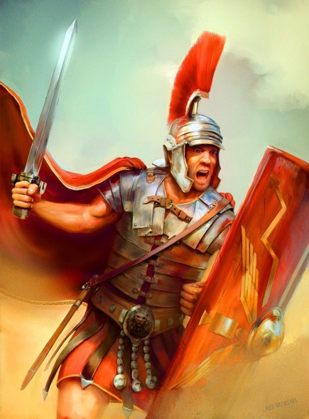
Paul gives us three examples of endurance:

Example #1: a soldier
2 Timothy 2:3,4
You therefore must endure hardship as a good soldier of Jesus Christ. No one engaged in warfare entangles himself with the affairs of this life, that he may please him who enlisted him as a soldier.

Q – Why do you think that Paul would use the example of a soldier?

Paul speaks of a soldier who never gets “entangled” with the affairs of this life. In other words, he is in the world, but not of the world. Here are a few other passages to consider:

1 John 2:15-17
Do not love the world or the things in the world. If anyone loves the world, the love of the Father is not in him. For all that is in the world—the lust of the flesh, the lust of the eyes, and the pride of life—is not of the Father but is of the world. And the world is passing away, and the lust of it; but he who does the will of God abides forever.
Luke 8:14
Now the ones that fell among thorns are those who, when they have heard, go out and are choked with cares, riches, and pleasures of life, and bring no fruit to maturity.
1 Timothy 6:9-12
But those who desire to be rich fall into temptation and a snare, and into many foolish and harmful lusts which drown men in destruction and perdition. For the love of money is a root of all kinds of evil, for which some have strayed from the faith in their greediness, and pierced themselves through with many sorrows. But you, O man of God, flee these things and pursue righteousness, godliness, faith, love, patience, gentleness. Fight the good fight of faith, lay hold on eternal life, to which you were also called and have confessed the good confession in the presence of many witnesses.
2 Peter 2:20
For if, after they have escaped the pollutions of the world through the knowledge of the Lord and Savior Jesus Christ, they are again entangled in them and overcome, the latter end is worse for them than the beginning.

Example #2 - an athlete
2 Timothy 2:5
And also if anyone competes in athletics, he is not crowned unless he competes according to the rules.

Q – Why does he use the example of an athlete?

One thing is certain: God will not “change the rules” just because he likes you or because you are a nice person.

1 Corinthians 9: 24-27
Do you not know that those who run in a race all run, but one receives the prize? Run in such a way that you may obtain it. And everyone who competes for the prize is temperate in all things. Now they do it to obtain a perishable crown, but we for an imperishable crown. Therefore I run thus: not with uncertainty. Thus I fight: not as one who beats the air. But I discipline my body and bring it into subjection, lest, when I have preached to others, I myself should become disqualified.

Example #3: a farmer – who must work hard and be patient.

2 Timothy 2:6
The hardworking farmer must be first to partake of the crops.

Q – What can we learn from a farmer? What principle is Paul illustrating in this next passage?
1 Corinthians 9: 7-11
Who ever goes to war at his own expense? Who plants a vineyard and does not eat of its fruit? Or who tends a flock and does not drink of the milk of the flock? Do I say these things as a mere man? Or does not the law say the same also? For it is written in the law of Moses, "YOU SHALL NOT MUZZLE AN OX WHILE IT TREADS OUT THE GRAIN." Is it oxen God is concerned about? Or does He say it altogether for our sakes? For our sakes, no doubt, this is written, that he who plows should plow in hope, and he who threshes in hope should be partaker of his hope. If we have sown spiritual things for you, is it a great thing if we reap your material things?

God will reward all of us according to our deeds, both in this life and in the life to come. He will never forget our labors and will deal with those who oppose His servants.

Hebrews 6:10-12
For God is not unjust to forget your work and labor of love which you have shown toward His name, in that you have ministered to the saints, and do minister. And we desire that each one of you show the same diligence to the full assurance of hope until the end, that you do not become sluggish, but imitate those who through faith and patience inherit the promises.

Galatians 6:7-10
Do not be deceived, God is not mocked; for whatever a man sows, that he will also reap. For he who sows to his flesh will of the flesh reap corruption, but he who sows to the Spirit will of the Spirit reap everlasting life. And let us not grow weary while doing good, for in due season we shall reap if we do not lose heart. Therefore, as we have opportunity, let us do good to all, especially to those who are of the household of faith.

In summary, here are three specific instructions that Paul gave to Timothy and that we should also receive and follow:

- Be strong in the grace that God gives us
- Pass on what you have heard
- Endure hardship

Keep Your Focus

I
f you are a believer and the Holy Spirit is working in you, sooner or later you are going to become less and less selfish and more concerned for the salvation and welfare of others. You may have started your journey thinking only of yourself, but the more you learn to love Jesus the more you will end up thinking of others. You will become as tough as a soldier, you will train like an athlete, and you will work hard like a farmer. This is because the Spirit of God is in you and because Jesus becomes your Lord, Master, Ruler.

In the first part of chapter 2 (vs. 1-7) Paul told Timothy to be strong and gave him these three examples, which are also examples for us to follow:

- A soldier who endures hardship
- An athlete who competes according to the rules
- A farmer who is hardworking

In the second part of chapter 2 he uses a key word: remember! Paul is encouraging Timothy to call to mind the reason why he had suffered so much. He is reminding him to keep his focus!
2 Timothy 2:8-13
Remember that Jesus Christ, of the seed of David, was raised from the dead according to my gospel, for which I suffer trouble as an evildoer, even to the point of chains; but the word of God is not chained. Therefore I endure all things for the sake of the elect, that they also may obtain the salvation which is in Christ Jesus with eternal glory. This is a faithful saying:
For if we died with Him,
We shall also live with Him.
If we endure,
We shall also reign with Him.
If we deny Him,
He also will deny us.
If we are faithless,
He remains faithful; He cannot deny Himself.

Jesus is the Messiah, the promised one, who proved it by his resurrection. This is the center of what we believe and what we preach.

There are actually three things that Timothy was told to remember in this passage that are extremely important and were the focal point of Paul’s life and ministry:

- The resurrection (vs. 8,9)
- The elect (v. 10)
- The reward (v. 11)

#1 - The resurrection:
2 Timothy 2:8,9
Remember that Jesus Christ, of the seed of David, was raised from the dead according to my gospel, for which I suffer trouble as an evildoer, even to the point of chains; but the word of God is not chained.
Q – Why is the resurrection so important? Have a look at 1 Corinthians 15:12-34

The resurrection proves:
- …that Jesus is the Messiah, the descendant of David, the savior of the world.
- …that Jesus has the power to change and deliver anyone who believes.
- …that we will rise again to a new life.

Luke 24:46 ,47
Then He said to them, "Thus it is written, and thus it was necessary for the Christ to suffer and to rise from the dead the third day, and that repentance and remission of sins should be preached in His name to all nations, beginning at Jerusalem.

So, the first thing to focus on is the resurrection of Jesus. What is the second thing to remember?

#2 - The elect:
2 Timothy 2:10
Therefore I endure all things for the sake of the elect, that they also may obtain the salvation which is in Christ Jesus with eternal glory.

Q – What is meant here by the “elect”?

Paul understood that the sufferings, persecutions and afflictions that he endured were for the sake of others. He knew that his struggles would allow Christ to be seen in him and that the things he suffered would encourage those who had to suffer in a similar way.

2 Corinthians 1:5-7 (New Living Translation)
For the more we suffer for Christ, the more God will shower us with his comfort through Christ. Even when we are weighed down with troubles, it is for your comfort and salvation! For when we ourselves are comforted, we will certainly comfort you. Then you can patiently endure the same things we suffer. We are confident that as you share in our sufferings, you will also share in the comfort God gives us.

So, we focus on the resurrection of Jesus, and the elect that need to be saved. What is the third thing to remember?
3 - The reward:
2 Timothy 2:11-13
This is a faithful saying:
For if we died with Him,
We shall also live with Him.
If we endure,
We shall also reign with Him.
If we deny Him,
He also will deny us.
If we are faithless,
He remains faithful; He cannot deny Himself.

Q – What does it mean to “die with Him?”

Romans 6:4-8
Therefore we were buried with Him through baptism into death, that just as Christ was raised from the dead by the glory of the Father, even so we also should walk in newness of life. For if we have been united together in the likeness of His death, certainly we also shall be in the likeness of His resurrection, knowing this, that our old man was crucified with Him, that the body of sin might be done away with, that we should no longer be slaves of sin. For he who has died has been freed from sin. Now if we died with Christ, we believe that we shall also live with Him,

Q – What does it mean to “reign with Him?”

Matthew 19:28,29
So Jesus said to them, "Assuredly I say to you, that in the regeneration, when the Son of Man sits on the throne of His glory, you who have followed Me will also sit on twelve thrones, judging the twelve tribes of Israel. And everyone who has left houses or brothers or sisters or father or mother or wife or children or lands, for My name's sake, shall receive a hundredfold, and inherit eternal life.

Q – In what way can someone who claims to know God deny Him? Is it possible for a true believer to deny Him?

Matthew 10:32,33
Therefore whoever confesses Me before men, him I will also confess before My Father who is in heaven. But whoever denies Me before men, him I will also deny before My Father who is in heaven.

Q – What about this verse: “If we are faithless, He remains faithful; He cannot deny Himself”. Can a true believer be faithless?

It doesn’t matter what we or others believe, He is still faithful to His word and will complete His purposes. God’s faithfulness is not affected by human unbelief (C. H. Spurgeon).

Romans 3:3,4
For what if some did not believe? Will their unbelief make the faithfulness of God without effect? Certainly not! Indeed, let God be true but every man a liar. As it is written: "THAT YOU MAY BE JUSTIFIED IN YOUR WORDS, AND MAY OVERCOME WHEN YOU ARE JUDGED."

Numbers 23:19
"God is not a man, that He should lie,
Nor a son of man, that He should repent.
Has He said, and will He not do?
Or has He spoken, and will He not make it good?

Titus 1:2
in hope of eternal life which God, who cannot lie, promised before time began,

So, in these last days we must not just mingle with the crowd. We must remember to remain focused on that which is most important:

- Remember the resurrection – proof that Jesus is the savior and can save and deliver anyone
- Remember the elect – there are still some out there of whom God wants us to testify so that they can be saved
- Remember the reward –
  - if we die, we live
  - if we endure, we reign
  - if we deny, He will deny
  - if we lose faith, He will still be faithful

Keep your focus!

Be Patient, God Is Up To Something!

A
fter all that we have learned about the difficulties of these last days, here is what we must always remember:

Be patient! Stay focused! God is up to something!
If you have been a Christian for a while, you probably have read the story of Joseph in the book of Genesis. I want to look at what happened to Joseph in order to show you something that you may not have perceived before. First let me recap what happened to this man:

Because of his father’s favoritism, he was hated by his brothers:

Genesis 37:2-4
This is the history of Jacob. Joseph, being seventeen years old, was feeding the flock with his brothers. And the lad was with the sons of Bilhah and the sons of Zilpah, his father's wives; and Joseph brought a bad report of them to his father. Now Israel loved Joseph more than all his children, because he was the son of his old age. Also he made him a tunic of many colors. But when his brothers saw that their father loved him more than all his brothers, they hated him and could not speak peaceably to him.

Q - Joseph had family problems. Do you have issues in your family?

God gave him a hint of what his purpose would be:

Genesis 37:9-11
Then he dreamed still another dream and told it to his brothers, and said, "Look, I have dreamed another dream. And this time, the sun, the moon, and the eleven stars bowed down to me." So he told it to his father and his brothers; and his father rebuked him and said to him, "What is this dream that you have dreamed? Shall your mother and I and your brothers indeed come to bow down to the earth before you?" And his brothers envied him, but his father kept the matter in mind.

Q - God had a plan for his life. Does God have a plan for your life?

His brothers sell him into slavery and he ends up in an ungodly place; Egypt:

Genesis 37:27,28
Come and let us sell him to the Ishmaelites, and let not our hand be upon him, for he is our brother and our flesh." And his brothers listened. Then Midianite traders passed by; so the brothers pulled Joseph up and lifted him out of the pit, and sold him to the Ishmaelites for twenty shekels of silver. And they took Joseph to Egypt.

Q - Do you ever feel as if you don’t belong where you are?

Joseph is blessed by God, but his integrity gets him in trouble:
Genesis 39:6-9
Thus he left all that he had in Joseph's hand, and he did not know what he had except for the bread which he ate. Now Joseph was handsome in form and appearance. And it came to pass after these things that his master's wife cast longing eyes on Joseph, and she said, "Lie with me." But he refused and said to his master's wife, "Look, my master does not know what is with me in the house, and he has committed all that he has to my hand. There is no one greater in this house than I, nor has he kept back anything from me but you, because you are his wife. How then can I do this great wickedness, and sin against God?"

Q - Have you ever been in trouble for doing the right thing?

He ends up in prison in Egypt, but God is with him even there:

Genesis 39:20,21
Then Joseph's master took him and put him into the prison, a place where the king's prisoners were confined. And he was there in the prison. But the LORD was with Joseph and showed him mercy, and He gave him favor in the sight of the keeper of the prison.

Q - Have you ever been in a difficult place?

Two years later, God speaks to Pharoah in a dream and Joseph rises to power:

Genesis 41:38-41
And Pharaoh said to his servants, "Can we find such a one as this, a man in whom is the Spirit of God?" Then Pharaoh said to Joseph, "Inasmuch as God has shown you all this, there is no one as discerning and wise as you. You shall be over my house, and all my people shall be ruled according to your word; only in regard to the throne will I be greater than you." And Pharaoh said to Joseph, "See, I have set you over all the land of Egypt."

With all that happened to Joseph, (betrayal, slavery and even prison), he stayed focus on what God had showed him in his dream. However, God was up to something much more:

- There was something that God did for Joseph’s immediate family:

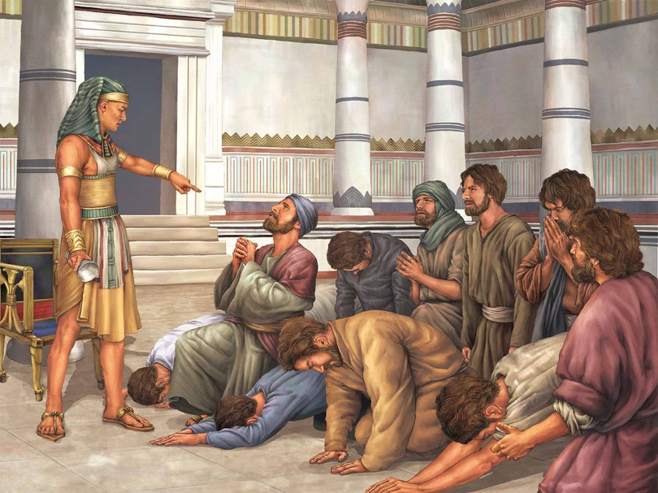
Genesis 45:4-7
And Joseph said to his brothers, "Please come near to me." So they came near. Then he said: "I am Joseph your brother, whom you sold into Egypt. But now, do not therefore be grieved or angry with yourselves because you sold me here; for God sent me before you to preserve life. For these two years the famine has been in the land, and there are still five years in which there will be neither plowing nor harvesting. And God sent me before you to preserve a posterity for you in the earth, and to save your lives by a great deliverance.

Joseph had no idea that his troubles were going to save the lives of his entire family.

Q – Is God doing something in your family?

- There was something that God did for many people in that day:

Genesis 50:20
But as for you, you meant evil against me; but God meant it for good, in order to bring it about as it is this day, to save many people alive.

Joseph had no idea that his troubles would save the lives of many people.

Q – Is God at work in our city and nation, even though it seems as if trouble has come?

- There was something bigger that Jacob and Joseph understood:

Genesis 49:28-32
All these are the twelve tribes of Israel, and this is what their father spoke to them. And he blessed them; he blessed each one according to his own blessing. Then he charged them and said to them: "I am to be gathered to my people; bury me with my fathers in the cave that is in the field of Ephron the Hittite, in the cave that is in the field of Machpelah, which is before Mamre in the land of Canaan, which Abraham bought with the field of Ephron the Hittite as a possession for a burial place. There they buried Abraham and Sarah his wife, there they buried Isaac and Rebekah his wife, and there I buried Leah. The field and the cave that is there were purchased from the sons of Heth."

Genesis 50:24
And Joseph said to his brethren, "I am dying; but God will surely visit you, and bring you out of this land to the land of which He swore to Abraham, to Isaac, and to Jacob." Then Joseph took an oath from the children of Israel, saying, "God will surely visit you, and you shall carry up my bones from here."

Why did it matter where they was going to be buried? Because Jacob and Joseph understood that God was going to bring them back to the land that He had promised them.

Q – Is there something happening that God wants you to understand?

Both Jacob and Joseph understood the promise that God made to Abraham and realized that there was something more. They began to focus on the eternal instead of the physical.

Hebrews 11:13-16
These all died in faith, not having received the promises, but having seen them afar off were assured of them, embraced them and confessed that they were strangers and pilgrims on the earth. For those who say such things declare plainly that they seek a homeland. And truly if they had called to mind that country from which they had come out, they would have had opportunity to return. But now they desire a better, that is, a heavenly country. Therefore God is not ashamed to be called their God, for He has prepared a city for them.

Joseph understood that God had a purpose that was far bigger than their immediate circumstances. He embraced it, and kept his focus on God’s purpose for the future:

Hebrews 11:22
By faith Joseph, when he was dying, made mention of the departure of the children of Israel, and gave instructions concerning his bones.

Are you a child of God? Do you love God? Even though you may not realize it, understand it, or even know it, God is at work for good!

Romans 8:28-30
And we know that all things work together for good to those who love God, to those who are the called according to His purpose. For whom He foreknew, He also predestined to be conformed to the image of His Son, that He might be the firstborn among many brethren. Moreover whom He predestined, these He also called; whom He called, these He also justified; and whom He justified, these He also glorified.
1Peter 5:10,11
But may the God of all grace, who called us to His eternal glory by Christ Jesus, after you have suffered a while, perfect, establish, strengthen, and settle you. To Him be the glory and the dominion forever and ever. Amen.

Be patient! Stay focused! God is up to something!
God Will Reward You!

Purpose: to encourage believers who may be discouraged to keep doing good, knowing that you will reap what you sow and that your labor is not in vain.
D
o you ever feel that things seem to get worse when you try to do good? Do you ever get discouraged when you see ungodly people that seem to prosper, yet things remain difficult for you. Does it bother you when people do wrong and seem to get away with it? Well, you are not the first:

Psalm 73:1 – 16
A Psalm of Asaph.
God is good to Israel,
To such as are pure in heart.
But as for me, my feet had almost stumbled;
My steps had nearly slipped.
For I was envious of the boastful,
When I saw the prosperity of the wicked.
For there are no pangs in their death,
But their strength is firm.
They are not in trouble as other men,
Nor are they plagued like other men.
Therefore pride serves as their necklace;
Violence covers them like a garment.
Their eyes bulge with abundance;
They have more than heart could wish.
They scoff and speak wickedly concerning oppression;
They speak loftily.
They set their mouth against the heavens,
And their tongue walks through the earth.
Therefore his people return here,
And waters of a full cup are drained by them.
And they say, "How does God know?
And is there knowledge in the Most High?"
Behold, these are the ungodly,
Who are always at ease;
They increase in riches.
Surely I have cleansed my heart in vain,
And washed my hands in innocence.
For all day long I have been plagued,
And chastened every morning.
I had said, "I will speak thus,"
Behold, I would have been untrue to the generation of Your children.
When I thought how to understand this,
It was too painful for me—

Q - Do you ever feel that way that Asaph felt?

How did he feel about the wicked
- They are prospering but I am not…
- They are strong, even in death…
- They are proud…
- They are violent…
- They have so much material wealth…
- They laugh and make fun of the righteous…
- They are at ease and are rich…
- They say that God does not know…
How did he feel about himself:
- I have cleansed myself for nothing…
- I am troubled and disciplined every day…
- This is too painful for me!!!

Q - What changed his mind?

Psalm 73:17-19
Until I went into the sanctuary of God;
Then I understood their end.
Surely You set them in slippery places;
You cast them down to destruction.
Oh, how they are brought to desolation, as in a moment!
They are utterly consumed with terrors.

Good news: God is a righteous and fair judge! Most people do not live with the understanding that God will judge and reward both the wicked and the good, but it is true!

Galatians 6:7-9
Do not be deceived, God is not mocked; for whatever a man sows, that he will also reap. For he who sows to his flesh will of the flesh reap corruption, but he who sows to the Spirit will of the Spirit reap everlasting life. And let us not grow weary while doing good, for in due season we shall reap if we do not lose heart.

Don’t be fooled/deceived:
- By false prophets
- By deceiving spirits
- By those who seem to “get away with it”
- By your own desires
- Don’t deceive yourself, and don’t allow yourself to be deceived by others.

God is not mocked:
- You cannot imitate or pretend with Him
- You cannot make fun of Him and get away with it
- You cannot fool Him
- He knows what is in our heart and will deal with us accordingly

There is a law of sowing and reaping:

- If you sow to your flesh (living for the cravings of your sinful nature), you will reap corruption (physical and mo ral decay and ruin).
- If you sow to the Spirit (keeping in step with the Spirit of God) you will reap everlasting life.

So don’t get tired of doing good, for at the proper time you will reap the benefits of your works if you don’t give up!

1 Corinthians 15:50-58
Now this I say, brethren, that flesh and blood cannot inherit the kingdom of God; nor does corruption inherit incorruption. Behold, I tell you a mystery: We shall not all sleep, but we shall all be changed—in a moment, in the twinkling of an eye, at the last trumpet. For the trumpet will sound, and the dead will be raised incorruptible, and we shall be changed. For this corruptible must put on incorruption, and this mortal must put on immortality. So when this corruptible has put on incorruption, and this mortal has put on immortality, then shall be brought to pass the saying that is written: "DEATH IS SWALLOWED UP IN VICTORY." "O DEATH, WHERE IS YOUR STING? O HADES, WHERE IS YOUR VICTORY?" The sting of death is sin, and the strength of sin is the law. But thanks be to God, who gives us the victory through our Lord Jesus Christ. Therefore, my beloved brethren, be steadfast, immovable, always abounding in the work of the Lord, knowing that your labor is not in vain in the Lord.

As we look toward the future, we can be encouraged by the fact that God will reward us for our works, both in this life and in the life to come. Keep doing good! Your labor is not in vain!

Summary of Part 2:
So, here is a brief summary of what we have discussed:
- You (who have the right heart) are the salt of the earth and the light of the world
- You must therefore walk as children of light
- You must follow good examples, not the counsel of the ungodly
- You must be strong in the grace that God gives us
- You must pass on what you have heard
- You must endure hardship

Remember that God makes all of this possible by the power of His Spirit who lives in us and works through us. Living in Him gives us true purpose and allows us to enjoy living!

